**A**

**PROJECT REPORT**

**ON**

**EMPLOYEE MANAGEMENT**

Submitted by,

ANJANA K

CHN19AJ029

Group 10

845268

**CONTENTS**

|  |  |  |
| --- | --- | --- |
| **Serial No.** | **TITLE** | **Page no.** |
| **1.** | **Abstract** | **1** |
| **2.** | **Introduction** | **2** |
| **3.** | **Requirement Specification** | **3** |
| **4.** | **Architecture Design** | **4** |
|  | **a) Screen capture of user interface** | **5-6** |
| **5.** | **Conclusion and future scope** | **7** |
| **7** | **References** | **8** |

**ABSTRACT**

The Employee Registration Management System is a web application that is developed to manipulate the details of every employee in an organization. This application is mainly focused on an authorized user, say an Admin from HR department, who is able to manipulate the information regarding each employee. This software helps to track employee information every easily and effectively.

This is a user-friendly application and can be used without any dilemma. The Admin can add the employee information of newly joined associates, update employee information of existing employees or delete information of those who left the organization. This software helps in tracking updated information of every employee.

The design and construction of the software is very simple so that user can feel it appealing. It is an integration of many new technologies so that the software goes novel.

**INTRODUCTION**

The Employee Management System is developed to manipulate the details of every employee in an organization. This application can be used by an Admin who is able to manipulate the information regarding each employee. This software helps to track employee information every easily and effectively.

Employee Management System is a user-friendly application that allows to add, update, delete and store employee data. The data is stored in a database that is developed in MySQL. Data of an employee means details regarding the employee in organizational aspect. That is the employee ID, first name, last name, email id, contact number, gender, age, job location, BU info, project id, job title, date of joining the organization, and salary  are included so that each and every employee can be tracked uniquely based on any of the information. The software ensures hundred percentage usage of java codes only. The coding is also done in very structured manner. Due to independency of java on platforms, it can be used on every platform.

Java was chooses as the medium for programming because java also have got many advantages over other programming languages.

This application is developed for an employee manager where he is able to add new employees, view available stock and update/delete the employee details. It also has a search module where the assistant can search employee using a search bar.

The user interface is simple in design and it uses HTML5, CSS3, JavaScript, JSTL, Spring MVC UI Components etc. The middleware is composed of Spring MVC components and the Persistence provider includes Hibernate with MySQL 5+ version database.

**REQUIREMENT SPECIFICATION**

For building and executing this software, these requirements have to be followed.

1. Java 1.8+

JDK is an acronym for Java Development Kit. The Java Development Kit (JDK) is a software development environment which is used to develop java applications and applets. It physically exists. It contains JRE + development tools. JDK is an implementation of any one of the below given Java Platforms released by Oracle corporation: Standard Edition Java Platform, Enterprise Edition Java Platform, Micro Edition Java Platform. The JDK contains a private Java Virtual Machine (JVM) and a few other resources such as an interpreter/loader (Java), a compiler (javac), an archiver (jar), a documentation generator (Javadoc) etc. to complete the development of a Java Application.

2. Tomcat Server 7.0 or above

Apache Tomcat (sometimes simply "Tomcat") is an open-source implementation of the Java Servlet, JavaServer Pages, Java Expression Language and WebSocket technologies. Tomcat provides a "pure Java" HTTP web server environment in which Java code can runTomcat is developed and maintained by an open community of developers under the auspices of the Apache Software Foundation, released under the Apache License 2.0 license.

3. MySQL database 5.0 or above

MySQL is a relational database management system based on the Structured Query Language, which is the popular language for accessing and managing the records in the database. The data in MySQL database are stored in tables.

4. Eclipse IDE / STS 2018-2019

5. Maven 3.0 or above

Maven is a software project management and comprehension tool. Based on the concept of a project object model (POM), Maven can manage a project's build, reporting and documentation from a central place.

6. Junit 4

JUnit is a unit testing framework for the Java programming language. JUnit has been important in the development of test-driven development, and is one of a family of unit testing frameworks. Its main use is to write repeatable tests for our application code units.

**ARCHITECTURE DESIGN**

The architecture design is very structured.

The whole software design can be divided

mainly into 3 parts - WebUI, a middleware layer and a persistence layer.

Web UI is nothing but what is seen by the user. It is composed of HTML,CSS, JavaScript components etc and is very appealing and simple. The UI is kept simple so that every guidelines or instructions to the user can be directly given through UI.

The UI can be accessed with the help of any browsers only. This layer interact with the preceding layer.

Next is a server unit that consist of another four blocks - the Presentation layer, Business layer, Integration layer and a domain model.

The presentation layer is also called a Controller. This is responsible for all the controlling and coordination between web UI and the server. According to the mapping given to each jsp pages the controller does the necessary actions.

Next is the Business layer which is otherwise called as the service layer. The service layer helps in doing all the necessary calculations, application logics and functions related to business level actions. It act as the connector between controller and Dao.

Next is the integration layer or Dao that is responsible for getting connected to the database. All the methods that is developed through this web application like addition of employee details, deletion of employee details, updation etc are implemented into database by this layer.

Domain Model is the layer containing entity classes. Every POJO class relating to the application is included under this section.

The last layer, that is persistence layer is nothing but the database where all the information are getting stored or manipulated.

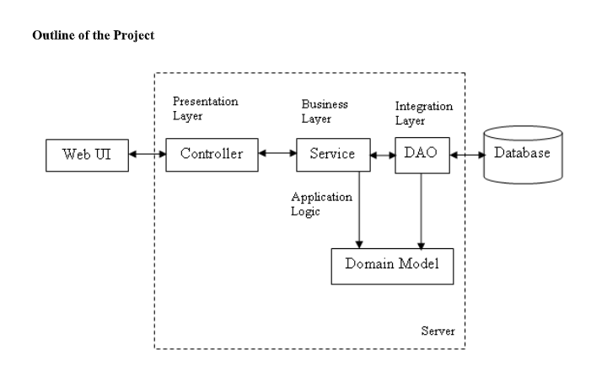

**SCREEN CAPTURES OF USER INTERFACE**

1. **Home page**

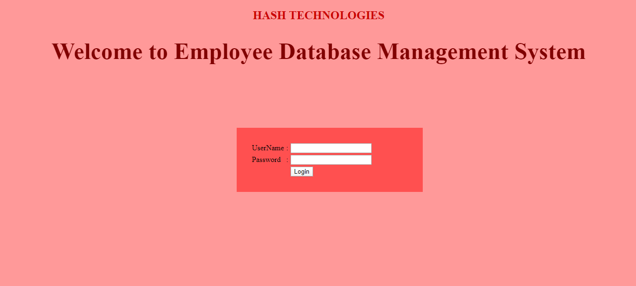

1. **Employee List page**

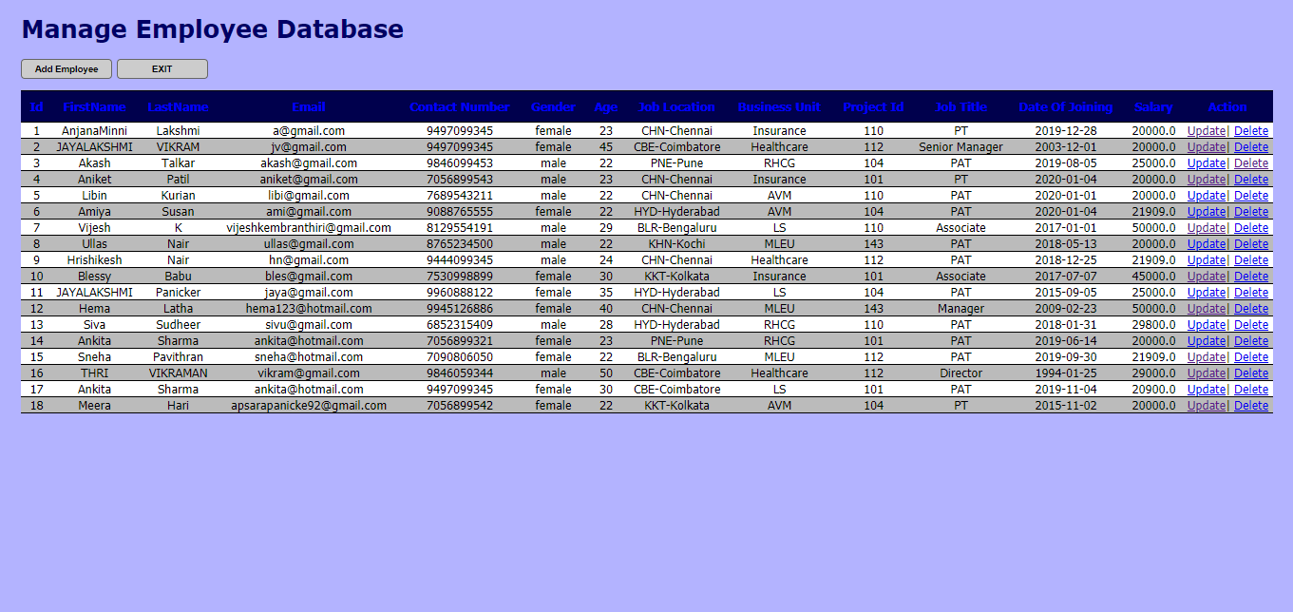

1. **Employee Addition page**

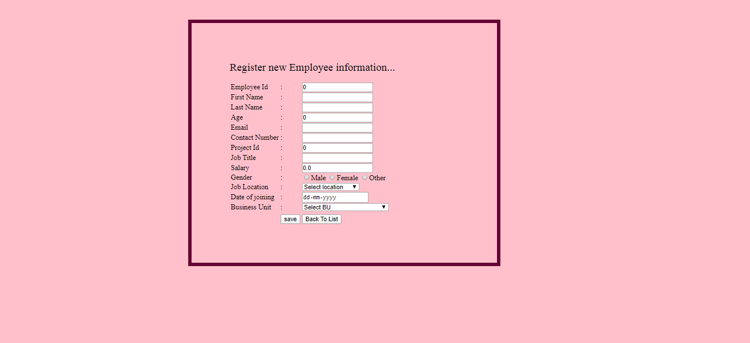

1. **Employee Update page**

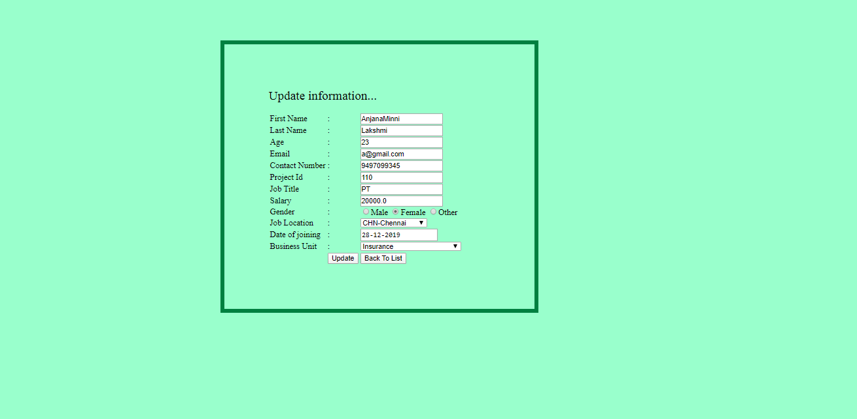

**CONCLUSION AND FUTURE WORK**

In this world of growing technologies everything has been computerized. With large number of work opportunities the Human workforce has increased. Thus there is a need of a system which can handle the data of a such a large number of Employees in an organization. This project simplifies the task of maintain records because its users friendly nature.

The "Employee Management System " has been developed to override the problems prevailing in the practicing manual system. This Web Application is supported to eliminate and in some cases reduce the hardships faced by this existing system.  Moreover this system is designed for the particular need of various companies to carry out the operations in a smooth and effective manner.

This application is reduced as much as possible to avoid the errors while entering the data. It also provides error messages while entering the invalid data. No formal knowledge is needed for the user to use this system. Thus by this all it proves it is user friendly.

In future, I would implement the web application as a mobile application supportable by both android and ios mobile phones. I would also try to implement some extra features in the Employee management web application like employee working hours, shifts and allowances, medical details etc. I would also like to modify our current UI to a more attractive UI by using angular in the future.

The application can be included with an employee access as well so that every employee is able to change or update their own details if required, but with more security constraints.

**REFERENCE**

1.https://docs.spring.io/spring/docs/current/spring-framework-reference/

2.https://docs.spring.io/spring/docs/current/spring-framework- reference/core.html#spring-core

3.https://docs.spring.io/spring/docs/current/spring-framework-reference/web.html

4.https://hibernate.org/orm/documentation/5.0/

5.https://maven.apache.org/guides/getting-started/index.html